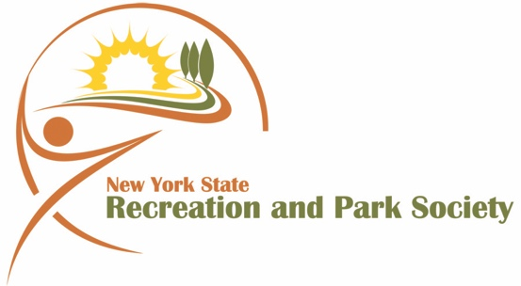

New York State Recreation and Parks Society
“Friends”

College Scholarship Program

This scholarship is available to undergraduates and graduate college students who are majoring in the Recreation, Parks, and Leisure Services field. A major in Physical Education does not meet the requirements of this scholarship.

Applicants must be residents of New York State and be attending an accredited college in New York State on a full-time or regular part-time basis.

It is the intent of the scholarship committee to award as many scholarships as financially possible on an annual basis, each in the amount of $750.00. The announcement of the scholarship winners will coincide with the Society’s 80th Annual Conference and Expo, scheduled this year from April 26-28, 2020 at the Westchester Marriott Hotel and Conference Center, 670 White Plains Rd., Tarrytown, New York 10591. Scholarships are presented as part of the formal annual awards ceremony on Monday, April 27th starting at 7:00 pm.

Scholarship awards will be made upon verification of successful completion of one full semester in the current year. Applicants will be judged on their academic record, leadership, co-curricular and out of school activities, resourcefulness, personal philosophy, professional affiliations and involvement. Scholarship awards will be made on the basis of this application and your supporting material. There will be no interviews.

Please note: All applications must be postmarked no later than March 30, 2020 to:

William V. Zimmermann, Chairman
NYSRPS “Friends Foundation Scholarship”
515 North Avenue
New Rochelle, NY 10801
(914) 654-2092
wzimmerm@newrochelleny.com

A scholarship committee has been appointed to review the applications and recommend the award winners. The committee’s decisions are final.

Required attachments:
College transcripts (Copies acceptable)
Three letters of recommendation
Additional support materials
New York State Recreation and Parks Society

“Friends Foundation”

College Scholarship Application

Please type or print clearly: Date
Ms. Mr. Miss. Mrs.

Name in Full

Last First Middle

College Address
College Phone ( ) *E-Mail ____________________________

Permanent Address
Permanent Phone ( ) *Cell __________________________

Date of Birth _______/_________/________ * required for notification purposes

Name of Father/Guardian Occupation
Name of Mother/Guardian Occupation

College currently attending
College Major (be specific)

COLLEGE EDUCATION
Dates Attended
Name of School Specific Major From – To

SUMMER OR YEAR ROUND EMPLOYMENT

Position Employer Address Dates

Please use the space below to write a description of your participation in activities such as aquatics, arts and crafts, athletics, camping, dance, music, student government, and club or parks maintenance.

Please list all current clubs or professional association memberships.

Please describe volunteer experiences you have had (specific information). Please note if experiences were required course work.

Please list any special awards or recognitions you have received.

Why did you choose a career in the Recreation and Parks Profession and what type of employment will you seek upon graduation? (Attach additional sheets, if more room is needed.)

Why do you feel that you are deserving of consideration for a scholarship from the “Friends” of Parks and Recreation?

List three adult non-relative references that are familiar with your character, commitment, achievements or work experience.

Name Relationship Phone Number

I HEREBY CERTIFY THAT ALL THE INFORMATION ON THIS APPLICATION IS CORRECT.

Signature of Applicant

Required Attachments:
College transcripts (Copies acceptable)
Three letters of recommendation
Additional materials

